**Programming for Prototyping**

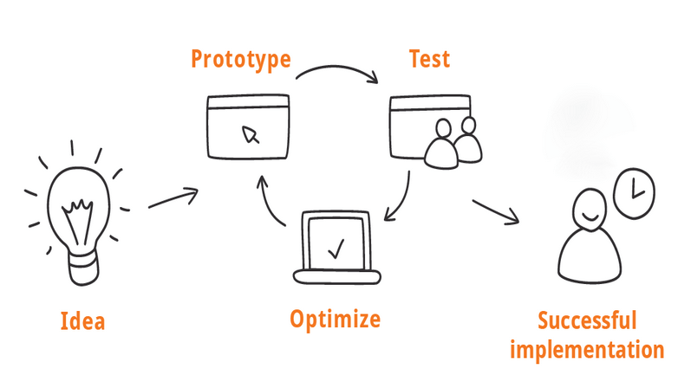

shorturl.at/korBF

**Robert Gatt**

**SM4391**

**9th April 2023**

**SMc20374**

**Programming for prototyping**

**Assignment 2 of 2**

**Section A**

**A1. Acceptance Document**

**User stories**

1. As a researcher, I want to be able to upload a covariance matrix text file in order to analyse my data.
2. As a researcher, I want to be able to upload a text file that includes all the fiducial parameters in order for the application to calculate the fisher matrix.
3. As a researcher, I want to be able to choose two parameters in order for the application to draw the error ellipses.
4. As a researcher, I would like to plot the error ellipses on a graph in the application.
5. As a researcher, I would like to see the error ellipses on the application.
6. As a researcher, I would like to be able to save a statistical report to a text file.

**Constraints and limitations**

1. This application needs to perform complex mathematical calculation on a large set of data; thus, the constraint is the limited processing resources, which might vary from user to user.
2. The application needs to be designed for cross-platform compatibility in order to support a large number of users. Cross-platform compatibility could therefore be a restriction.
3. The application's user interface (UI) must be simple, intuitive, and provide all the information, which may be a constraint given that different types of study may require different amounts of data.
4. Security is an issue; the files will be saved as a text file, which might be leaked or overwritten.
5. Depending on the level of functionality and features required by the research team, time restrictions in producing the final MVP (minimum viable product) could be a problem.
6. Because there are only a limited number of resources available, developing an application requires a budget, which may affect the number of features and functionality that the finished product will have.

**Prototypes that will be delivered**

1. Hand drawn storyboard portraying the environment, sequence and satisfaction of utilizing the application.
2. Couple of low-fidelity prototypes created using office supplies in order to choose the best option to prototype.
3. A PowerPoint mock-up of one of the chosen low-fidelity prototypes that will have the logical flow of how the user can use the application.
4. A high-fidelity mock-up of the GUI.
5. A high-fidelity graphical plot using a covariance matrix, with the following five parameters for the X and Y coordinates:
   1. Ωbh 2 vs Ωch 2,
   2. Ωch 2 vs w,
   3. ln(A) vs ns,
   4. τ vs w, and,
   5. user defined plots

**A2.1 Storyboard – Prototype 1**

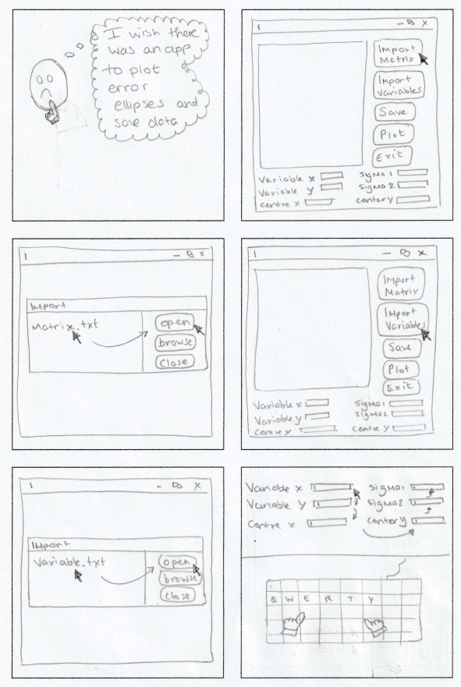

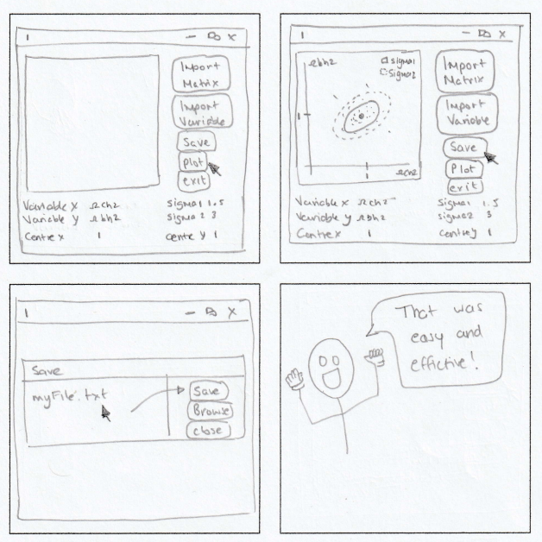

**A2.2 Storyboard – Prototype 2**

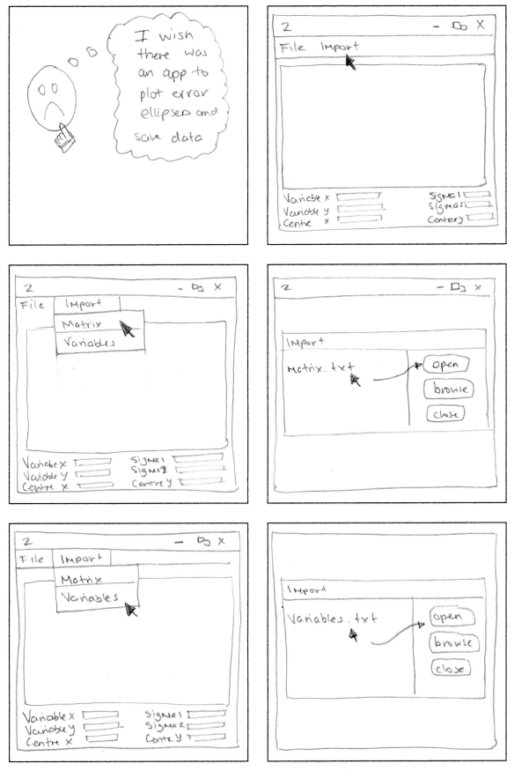

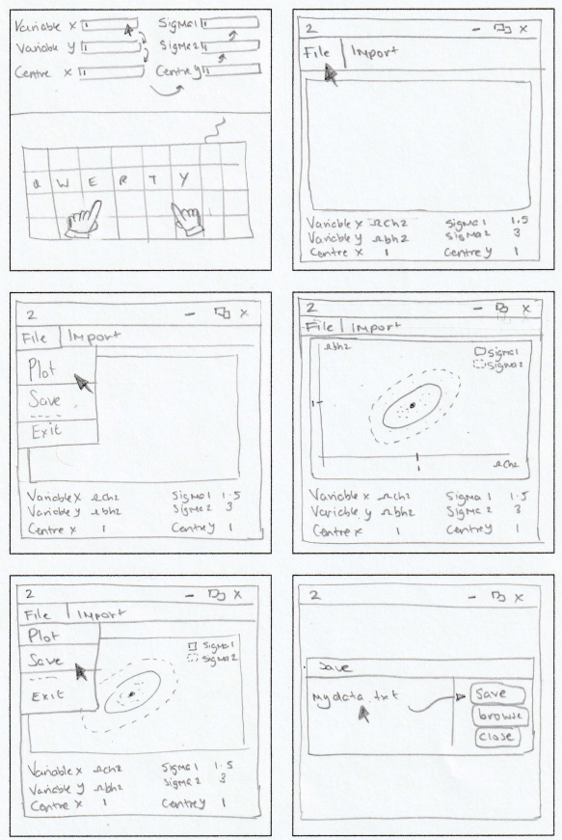



**A3.1.1 Office-stationary based prototype – hand-drawn sketch for prototype 1**

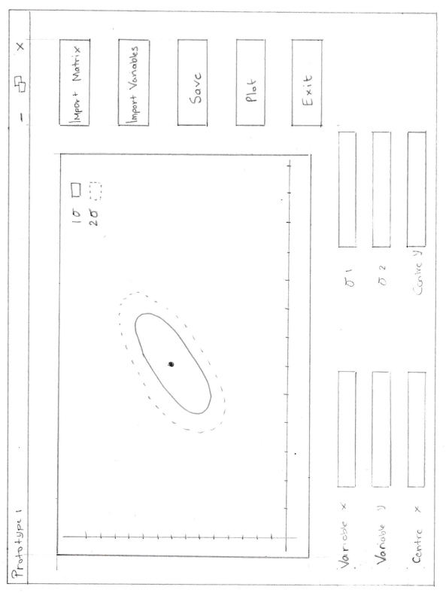

**A3.1.2 Office-stationary based prototype – variation one for prototype one**

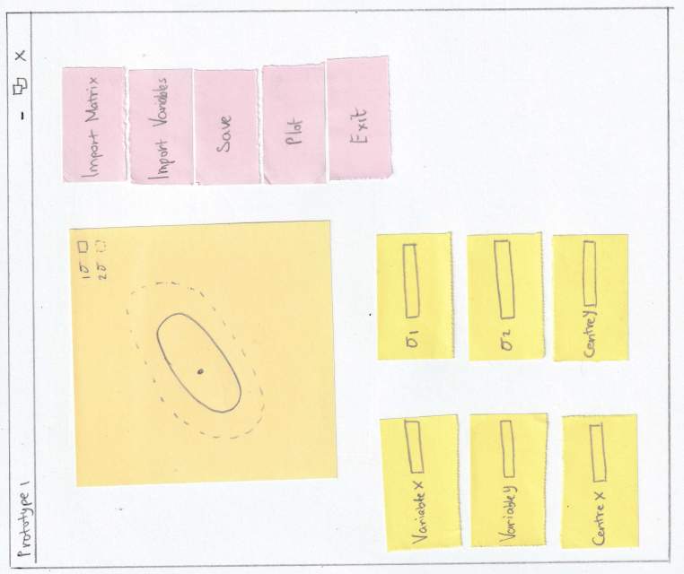

**A3.1.3 Office-stationary based prototype – variation two for prototype one**

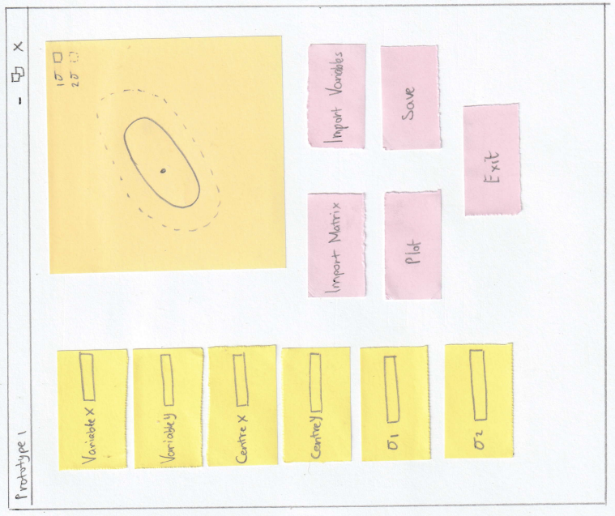

**A3.1.4 Office-stationary based prototype – variation three for prototype one**

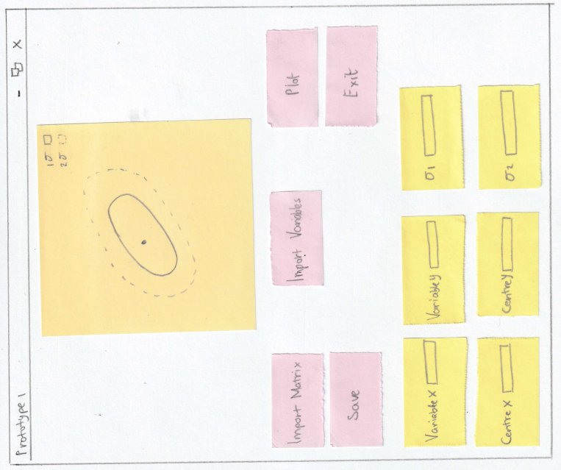

**A3.2.1 Office-stationary based prototype – hand-drawn sketch for prototype 2**

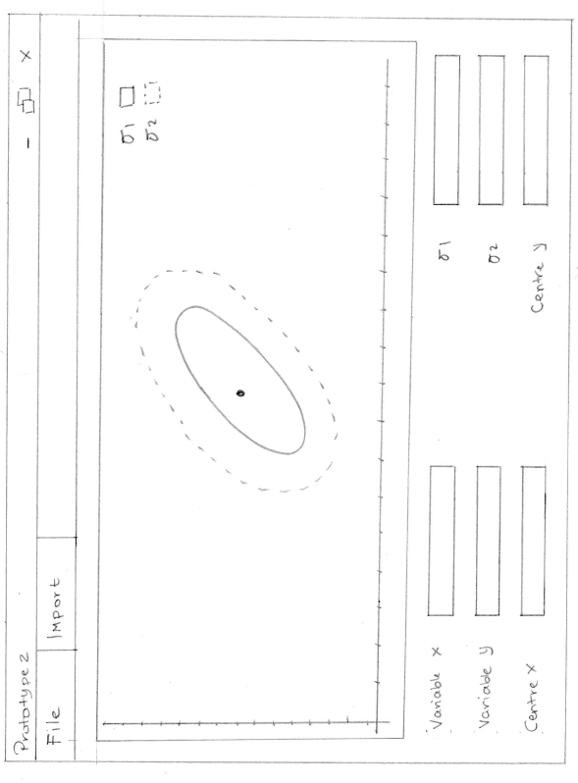

**A3.2.2 Office-stationary based prototype – variation one for prototype two**

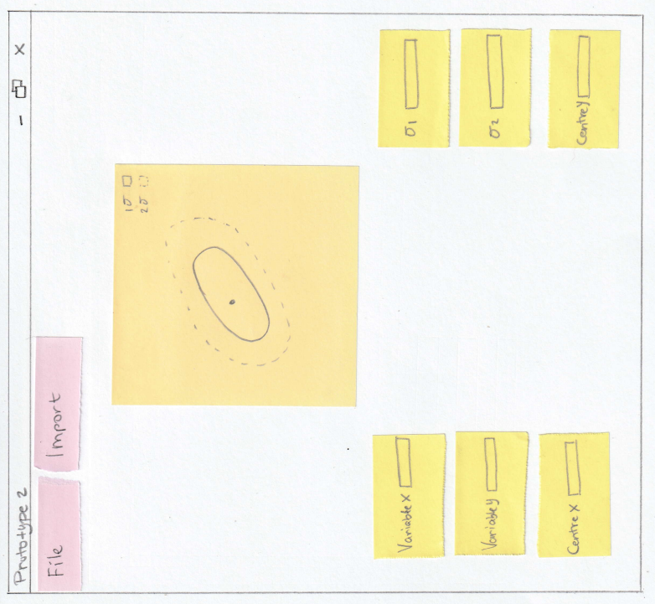

**A3.2.3 Office-stationary based prototype – variation two for prototype two**

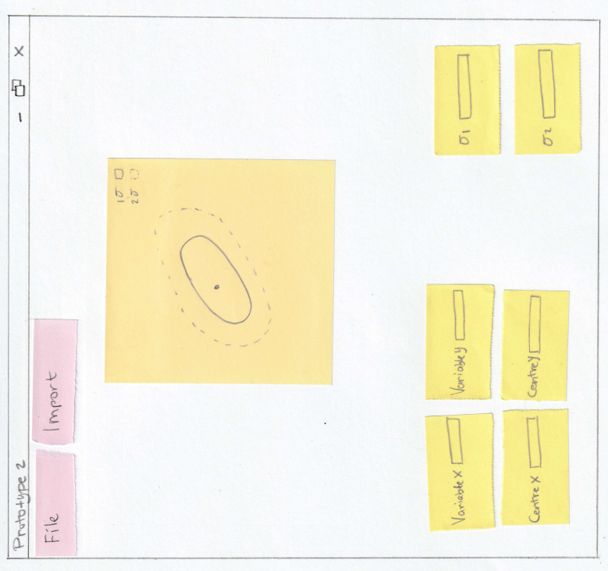

**A3.2.4 Office-stationary based prototype – variation three for prototype two**

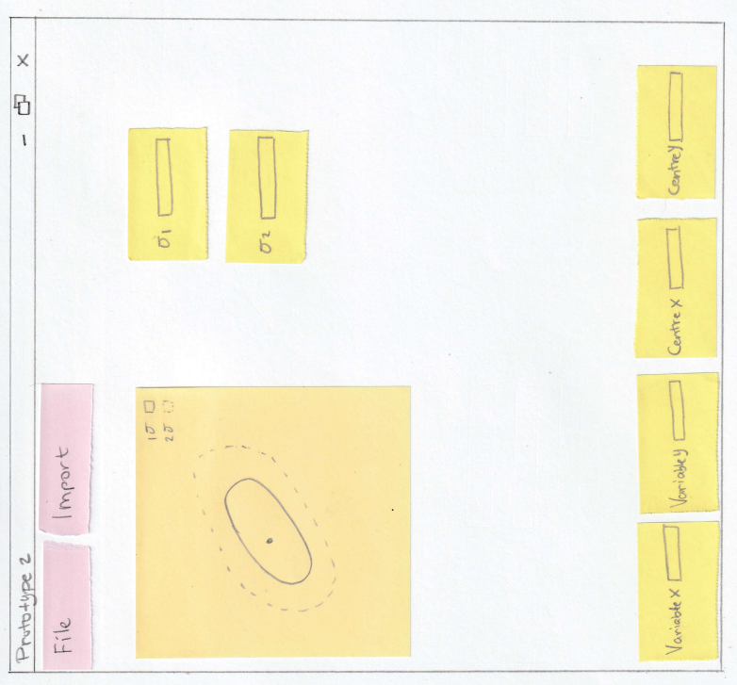

**A4. Power point mock-up**

*This is enclosed in the same zip folder as a separate file.*

**Section B**

**B1. Plan**

The plan for creating this prototype is to first develop the main UI to demonstrate to users how the application would look. Afterward, the main application will be implemented to display and plot five ellipses using a covariance matrix and five parameters for the X and Y values, four of which are predefined, and one is defined by the user.

* Ωbh 2 vs Ωch 2,
* Ωch 2 vs w,
* ln(A) vs ns,
* τ vs w, and,
* user defined plots

This prototype will make use of three libraries:

* tkinter
* matplotlib
* numpy

Tkinter is a built-in GUI package that provides a standard Python interface (Docs, 2023). Its main advantage is that it is easy to use and allows for the creation of fast prototypes. At this stage, the application does not contain many buttons or user inputs, making it easy to modify the UI based on user feedback. However, if the application were to grow and researchers require more functions and features, tkinter may need to be replaced by more sophisticated GUI packages such as PyJamas and WxPython.

*“Matplotlib is a comprehensive library for creating static, animated, and interactive visualizations in Python. Matplotlib makes easy things easy and hard things possible.”* (matplotlib, 2023)*.* Hence, the use of this library is ideal for this prototype, as it offers a wide variety of features, including plot and scatter, which are necessary for creating the required visualizations.

The last package to be used for this prototype is NumPy. According to its official website, NumPy provides “*powerful n-dimensional arrays*” (NumPy, 2023) and “*numerical computing tools*” (NumPy, 2023), making it ideal for the type of prototype required. Specifically, NumPy will be used to import the covariance matrix in *.covmat* file format and to compute the Fisher matrix using built-in functions for matrix inversion.

**B2. Flow chart**

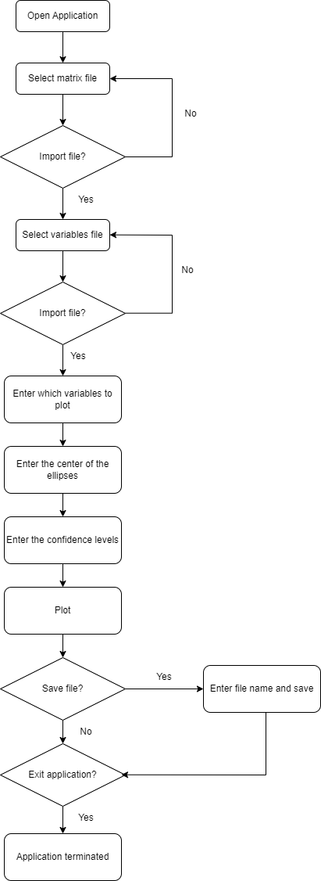

**B3. Interface – Documentation**

*Please note that the program has been attached together with this document and is named GUI.py.*

The work in section A served as the foundation, which is an illustration of the GUI rather than a finished product.

**B3.1:** **Imports**

The three required packages are imported first by the program; they are all included in the Python’s standard library.

* Tkinter: used to create graphical user interface using basic widgets.
* Matplotlib: used to plot the error ellipses and the Gaussian 500 random points.
* NumPy: used to generate the Gaussian 500 random points.

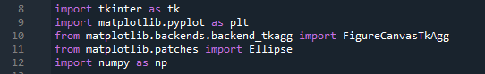

Figure 1 - Imports

**B3.2: Functions**

This program make use of five functions:

* importMatrixButton()
* saveButton()
* importVariablesButton()
* plotButton()
* exitButton()
* plot()

The functions from importMatrixButton() to exitButton() simply sends a message to the console whenever a button is pressed; this is because this application is just a graphical representation of the prototype.

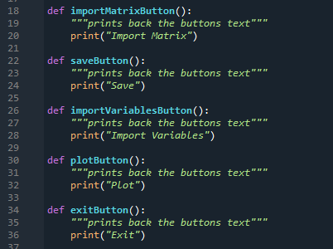

Figure 2 - Button functions

The plot() function on the other hand follows the following procedure:

* Assign predefined variables to be used to produce the 500 Gaussian random points and the error ellipses.
* Create two ellipse objects with the predefined parameters.
* Generate 500 random data points using the multivariant normal distribution.
* Add the ellipses and the data points to the plot.
* Make two rectangles to serve as a legend indicating which of the two ellipses is at whichever level of confidence, and place them in the top-right corner of the plot.
* Set the x and y axis labels.
* Make a red dot in the middle of the ellipses to mark the centre.
* Use tkinter’s canvas to plot the ellipses, points and centre of the ellipses.
* Show the plot in the GUI.

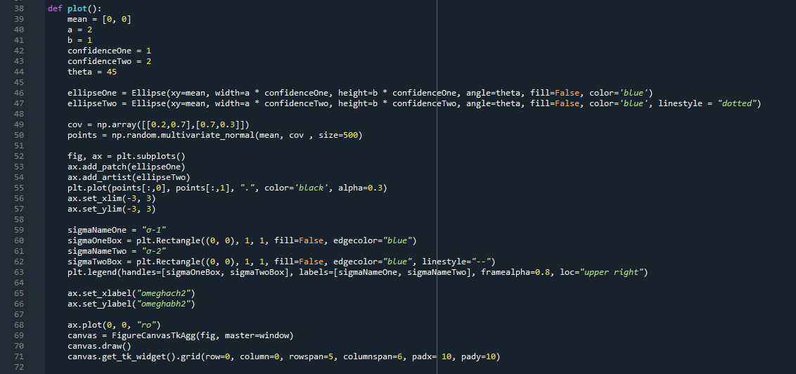

Figure 3 - Plot function

**B3.3: GUI**

The tkinter package is used to create the user interface. The application begins by assigning a title to the window and forbids the user from resizing it.

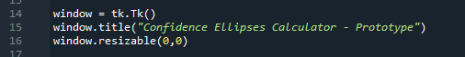

Figure 4 - GUI title and resizable to false

Afterwards, it generates labels and entries for:

* Variable X (ex: omegach2, w, ns, etc.)
* Variable Y (ex: omegach2, w, ns, etc.)
* Centre X (the X value of the centre of the ellipses)
* Centre Y (the Y value of the centre of the ellipses)
* Sigma 1 (the inner confidence value)
* Sigma 2 (the outer confidence value)

The labels and entries are placed on the screen based on the grid's row and column, with a 10pixel padding.

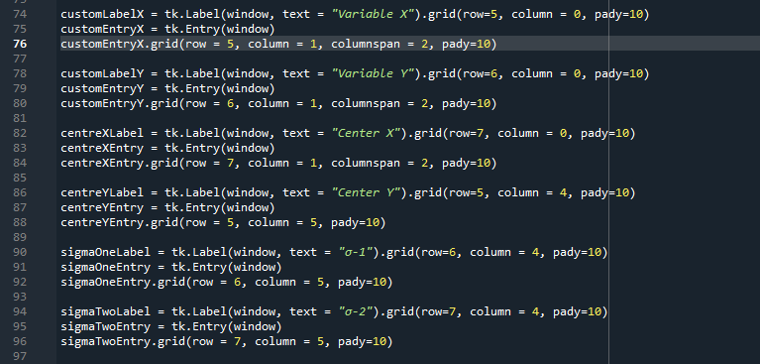

Figure 5 - GUI's Entry and Label fields

The final step in creating the GUI is to create the buttons. When they are clicked, the functions stated in the previous section are invoked. The buttons in this prototype do nothing.

Ultimately, the mainloop() method is used to generate the window.

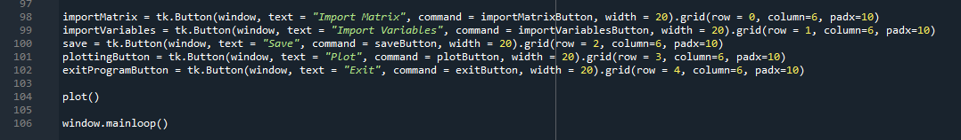

Figure 6 - Buttons and window generation

**B3.4: Prototype and the high-fidelity GUI**



Figure 7 – Prototype

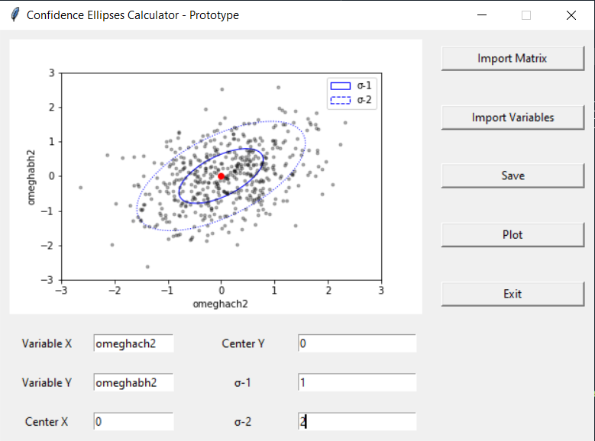

Figure 8 - GUI implementation using tkinter

**B4. Implementation - Documentation**

*Please note that the program has been attached together with this document and is named Fisher_Matrix.py.*

**B4.1 – Imports**

The two required packages are imported first by the program; they are all included in the Python’s standard library.

* Matplotlib: used to plot the error ellipses and the Gaussian 500 random points.
* NumPy: used throughout the program to work various mathematical formulas such as the inverse of the covariance matrix, square roots, inverse tangent and converting arrays to matrices.

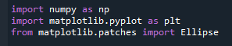

**B4.2 – Functions**

This program consists of various function, each of which has a specific purpose and is designed to follow the principle of single-responsibility programming.

* getHeaderVariables
* getFullDataMatrix
* printCovarianceAndFisherValues
* getFisherMatrix
* getCovarianceMatrix
* _calculateInnerFormula
* _calculateASquared
* _calculateBSqaured
* _calculateTanTwoTheta
* ellipse_params
* printEllipse_params
* plot

**B4.2.1 – getHeaderVariables**

This function does not take any parameters. Its purpose is to return the list of all the variable names extracted from the first line of the provided file:

*base_w_plikHM_TTTEEE_lowl_lowE_BAO_Riess18_Pantheon.covmat*

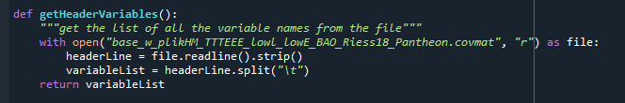

Figure 9 – getHeaderVariable function

**B4.2.2 – getFullDataMatrix**

This function does not take any parameters. Its purpose is to return the 28x28 matrix from the provided file:

*base_w_plikHM_TTTEEE_lowl_lowE_BAO_Riess18_Pantheon.covmat*

The matrix is acquired by skipping the header and extracting the values by splitting them using the tab delimiter.



Figure 10 – getFullDataMatrix function

**B4.2.3 – printCovarianceAndFisherValues**

This function takes four parameters:

* covarianceMatrix – this is the full covariance matrix extracted from the provided file
* fisherMatrix – this is the worked out fisher matrix using getFisherMatrix() method
* variableNameOne – this is the first variable name such as Ωbh2
* variableNameTwo – this is the second variable name such as Ωch2

The sole purpose of this function is to print the values of the passed parameters.

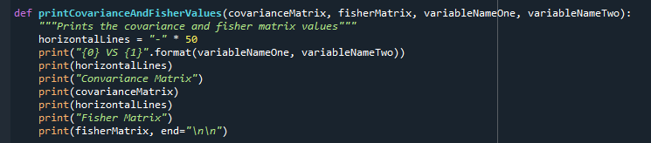

Figure 11 - printCovarianceAndFisherValues function

**B4.2.4 – getFisherMatrix**

This function takes one parameter:

* covarianceMatrix – this is the covariance matrix

This function returns the fisher matrix after inverting the covariance matrix using the NumPy linalg.inv() method

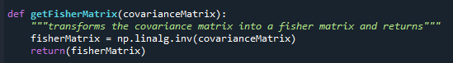

Figure 12 - getFisherMatrix function

**B4.2.5 – getCovarianceMatrix**

This function takes three parameters:

* variableNameOne – the variable name from the matrix such as omegabh2
* variableNameTwo – the variable name from the matrix such as omegach2
* fullDataMatrix – the 28x28 matrix extracted from the provided file.

The function first gets the index of the two variable names which are stored in the variableNames array. Afterwards, it extracts the values of x, xy and y depending on the index. Finally, the values are stacked in a 2x2 matrix and returned back to the caller.

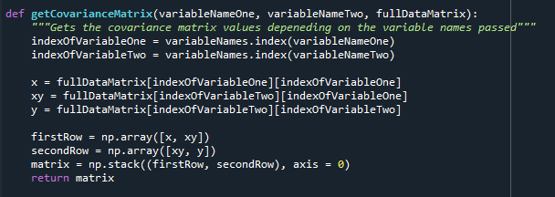

Figure 13 - getCovarianceMatrix function

**B4.2.6 – _calculateInnerFormula, _calculateASquared, _calculateBSquared, _calculateTanTwoTheta and ellipse_params**

These five functions are used to calculate and return the answer based on the formulas given below.

$$a^{2}=\frac{σ_{x}^{2}+σ_{y}^{2}}{2}+\sqrt{\frac{{\left(σ_{x}^{2}-σ_{y}^{2}\right)}^{2}}{4}+}σ_{xy}^{2}$$

$$b^{2}=\frac{σ_{x}^{2}+σ_{y}^{2}}{2}-\sqrt{\frac{{\left(σ_{x}^{2}-σ_{y}^{2}\right)}^{2}}{4}+}σ_{xy}^{2}$$

$$\tan\left(2θ\right)=\frac{2σ_{xy}}{σ_{x}^{2}-σ_{y}^{2}}$$

The ellipse_params function takes in four parameters:

* sigmaX - $σ_{x}^{2}$
* sigmaY - $σ_{y}^{2}$
* sigmaXY - $σ_{xy}$
* levelOfConfidence – a float value

The function returns the values of a, b and $θ$

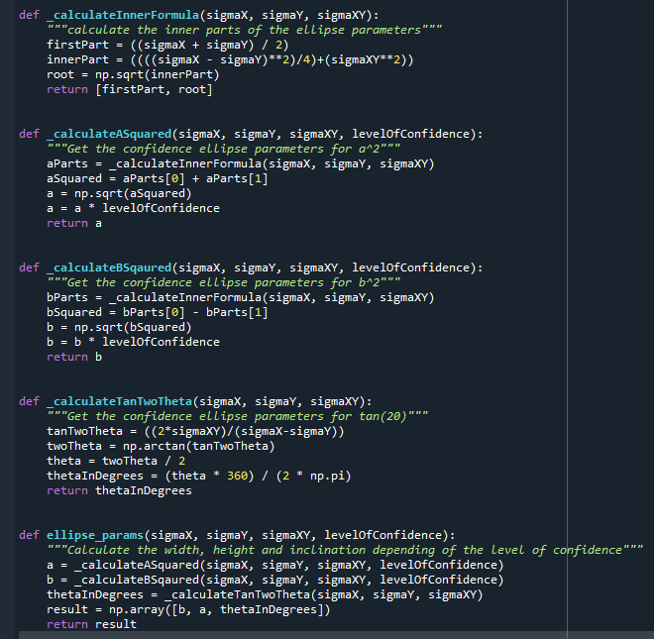

Figure 14 - calculations for a, b and $θ$ functions

**B4.2.7 – printEllipse_params**

This function takes two parameters:

* params – which is the array of all the ellipses parameter values (a, b and $θ$)
* name – the name of the x and y plotted coordinates for example Ωbh2 vs Ωch2

The sole purpose of this function is to print the parameters of the ellipse at α = 1.52 and the name of the x and y plotted values.



**B4.2.8 – plot**

The plot() function is the program’s final function, and it takes the following parameters:

* widthA – the width of the first ellipse
* widthB – the width of the second ellipse
* heightA – the height of the first ellipse
* heightB – the height of the second ellipse
* inclinationA – the theta in degrees of the first ellipse
* inclinationB – the theta in degrees of the second ellipse
* x – the x value for the centre
* y – the y value for the centre
* covarianceMatrix – the covariance matrix used to generate the Gaussian 500 random points
* variableNameX – the name of the x-axis
* vairableNameY – the name of the y-axis

First, the function creates two error ellipses using the Ellipse() class from matplotlib library. Afterwards, it generates 500 random points using the NumPy random.multivariate_normal method based on the covariance matrix.

Next, the function adds the random points and ellipses to the plot and adds a red dot to mark the center of the ellipses. It creates a legend in the top right-hand corner of the screen to show the two standard deviations.

Finally, the function plots the graphs using the plot.show() method.

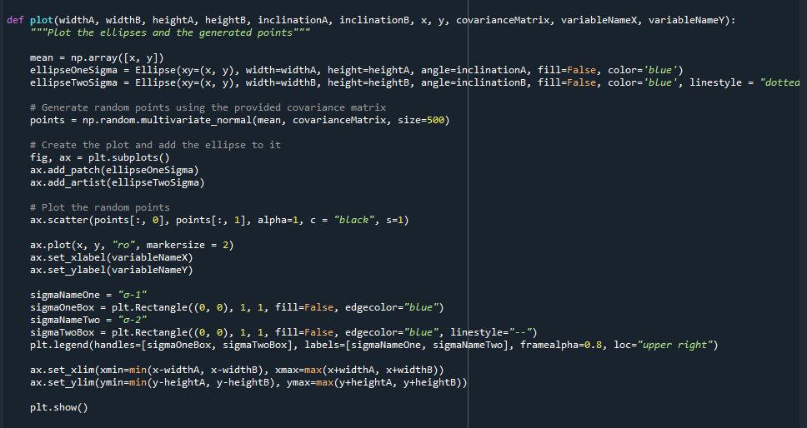

Figure 15 - plot function

**B4.3 – How the functions are called in sequence**

1. getHeaderVariables – used to fill up the variable name of variableNames
2. getFullDataMatrix – used to fill up the variable name fullDataMatrix

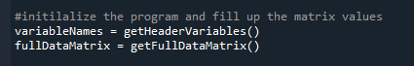

Figure 16 - setting up variableNames and fullDataMatrix variables

1. getCovarianceMatrix – used to get the covariance matrix from the specified variable names

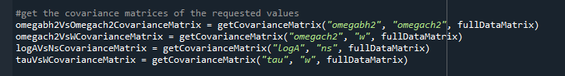

Figure 17 - setting up covariance matrix values

1. getFisherMatrix – used to transform the covariance matrix into a fisher matrix

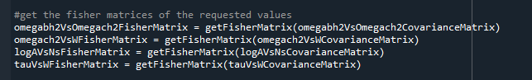

Figure 18 - setting up fisher matrix values

1. printCovarianceAndFisherValues – used to print to the console the covariance and fisher values of all four required parameters

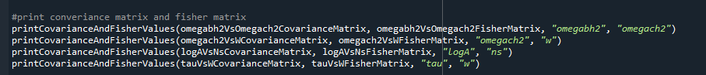

Figure 19 - print covariance and fisher values

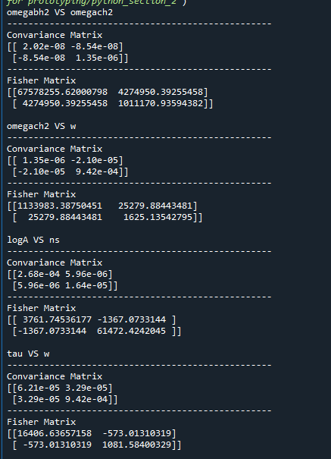

Figure 20 - printed values on the console

1. ellipse_params – used to get all the parameters (a, b, and $θ)$ for two separate confidence values (1.52 and 2.48)

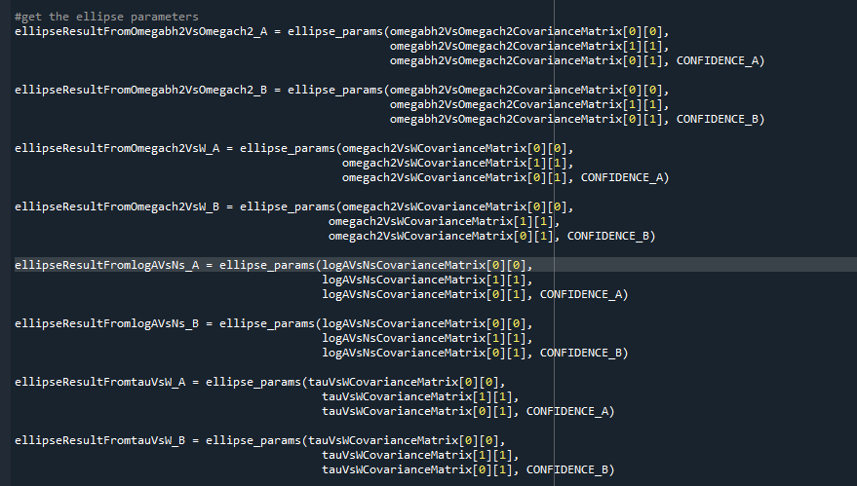

Figure 21 - setting up ellipses values

1. printEllipse_params – used to print to the console the ellipse parameters based on the confidence level of 1.52

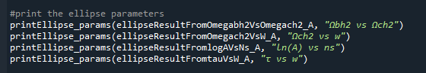

Figure 22 - printing the ellipse parameters to console

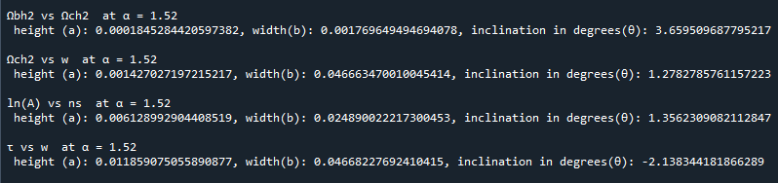

Figure 23 - console printing of ellipse parameters

1. A menu option stating is the user would like to print to the console the ellipse parameters based on user’s input of σx, σy, σxy and level of confidence.

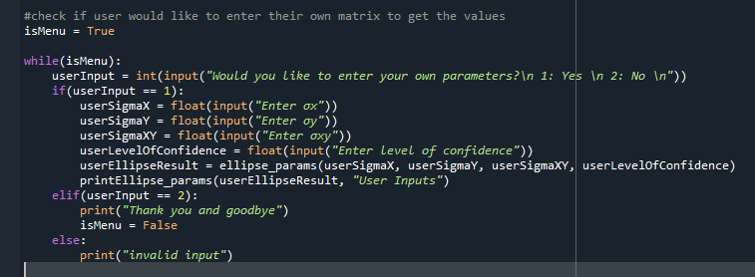

Figure 24 - menu code

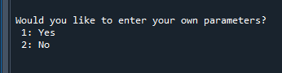

Figure 25 – menu asking the user if they would like input their own parameters

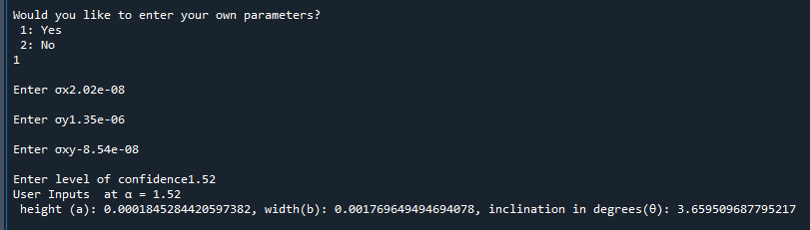

Figure 26 - printing to the console the ellipse parameters based on user's input

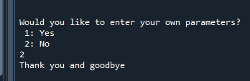

Figure 27 - exiting the program

**B4.4 – Plots**

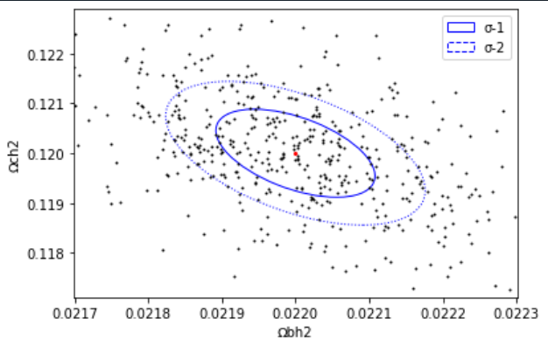

Figure 28 - Ωbh2 vs Ωch2

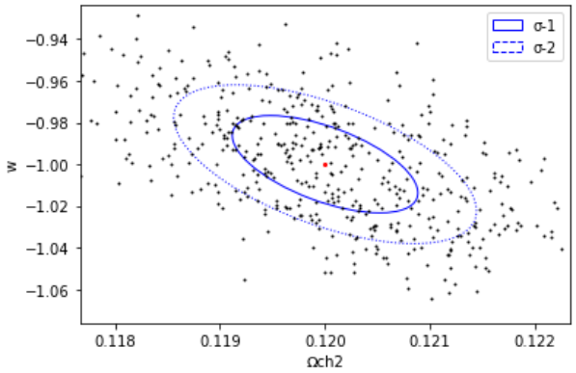

Figure 29 - Ωch2 vs w

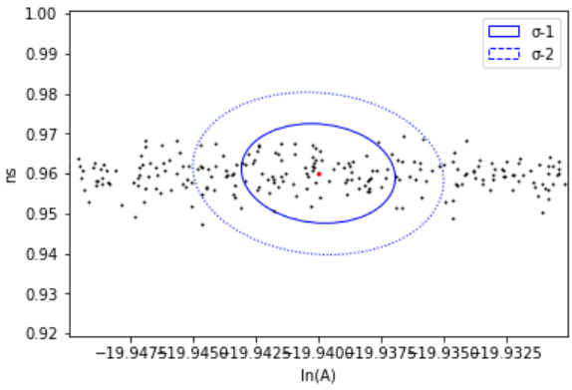

Figure 30 - ln(A) vs ns

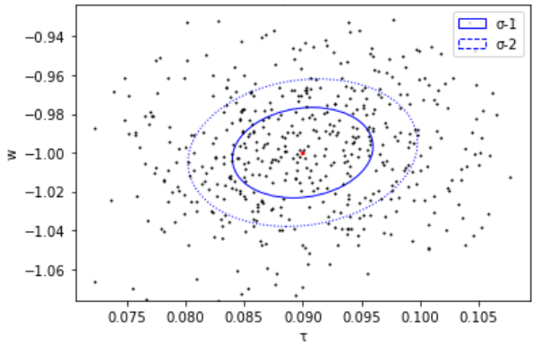

Figure 31 - t vs w

**B4.5 – Integrating Fisher_Matrix.py with the GUI**

*Please note that the program has been attached together with this document and is named GUI with Fisher.py.*

This program integrates the previous program mentioned in section 4.1 and the GUI prototype mentioned in section 3.1 into one program.

Because all of the features have been covered in the previous two sections, this section will merely cover an overview of the new functions.

**B4.6 – How it works**

**B4.7 – Plots**

# References

Docs, P. (2023, 04 11). *Python Docs*. Retrieved from tkinter — Python interface to Tcl/Tk: https://docs.python.org/3/library/tkinter.html

matplotlib. (2023, 04 11). *matplotlib*. Retrieved from Matplotlib: Visualization with Python: https://matplotlib.org/

NumPy. (2023, 04 11). *NumPy*. Retrieved from NumPy: https://numpy.org/